University of Houston

PRIME -PREDICTOR GAME

*ECE 6370*

*GROUP: NIGHTS KING*

*Team*

*Adithya Sekar - 1637408*

*AnishKumar Chouhan*

*Gokul Venugopal - 1824696*

*Joy Rebello - 1764719*

*Naveen Subramanian -*

Table of Contents

1. **ABSTRACT** 5

**CONCEPT** 7

**MODULES** 10

1. Button Shaper 10

2. Access Controller 13

3. Seven Segment Display 16

4. ADDER 19

5. TimerOneSecond 19

6. TimerLoad 20

7. TimerForEachDigit 21

8. Timer100ms 22

9. Timer1ms 22

10.Timer 23

11.successRounds 24

12.RandomNumberGen 24

13.CountTo100 25

14. CountTo10 25

**System Architecture** 26

**SIMULATION** 30

Access Control 30

Load Register 30

Button Shaper 31

Seven Segment 31

Random Number Generator 31

Timer 32

Timer1ms 33

Count To 100 34

Count To 10 34

successRounds 35

LAB 3 Top Test Module 35

**FPGA TESTING RESULT** 37

**Conclusion** 43

Appendix 43

**REFERENCES** 44

# **ABSTRACT**

A prediction game is a game which allow users to guess at the outcome of future events. Points are awarded to players who most accurately predict the outcome of an event, and those points are converted into cash prizes. Prediction Games have recently become popular on the internet. These speculative games offer topics ranging from the world of entertainment, sports, and finance to various world current events. Some gaming industry analysts are wary that this game may become highly addictive [1]. Our project is to create a prediction game that is easy to play but still challenge the user to some extent. To implement this, we are going to use FPGA board to generate a random number and an authentic user can score point for correct prediction of that number. Hint LEDs are provided to help user to understand the proximity of his value to the random number. To make it challenging for the user, random number will also be prime number and the range of values will be changed as the user scores in the game. Additional features include timer, multiuser authentication, user profile and highest score display.

# **INTRODUCTION**

The prediction game is implemented using FPGA where user can score point when they predict the prime number generated by FPGA. The game starts with user authenticating into the system. Maximum of 6 players can play this game and their user id/password is stored in ROM. Once user is authenticated, he needs to set timer value which determines how many seconds the user can play the game. Since, the idea is to predict, and user may not be able to predict in one round, it is required to help user to know how the proximity of the user input to the random number is generated. This is done with the help of hint reds that glow to indicate if user input is above or below the predicted prime number. Once user identifies the number, he scores a point. Maximum score is 99 and the user profile who scores the highest will be stored in the RAM as the highest scorer and can be viewed on FPGA. The random number generated will modified according to the game level to change the range of the prime number. Game Level is decided using the current score of the user. If score is less than 25 then range of prime number will also be less than 25, if user score is between 25 – 50 then the range of prime number can be between 0 – 50 and so forth. User can also reset, pause, re-config timer. LFSR is used to determine the random number which is then used to determine the prime number.

The features of the game are:

1. Access Control – This is to only those users who are authorized to play to use the system. This is also used to control the timer – reset, pause, start and re-config. For authentication, user id and password are required which can be given to the system through toggle switches and push buttons.
2. Timer – This feature determines the duration of the play a user can play a game. He can also pause, reset, and re-config using push button. Timer needs to be set before playing the game.
3. Random Prime Number – This feature uses LFSR to generate a random number which is then used to find the next prime number. This number is used to check with the user input to determine whether the user has guessed the right number.
4. User Profile – This feature is implemented in RAM and is used to store the user id and his current score. Maximum current score is 99 after that it resets to 00.
5. Score Board – This feature is used to display the current score of the user and is incremented when user predicts the random number. This feature is also used to find if the current user has scored the highest. If yes, then his user id and score is stored in RAM.
6. Level Adjust – This feature is used to make the game more challenging. This feature determines the range of prime number that could be generated by the random number generated. The feature is implemented in a way that it gets the user;s current score and then checks to find the range of values which the current score falls into. Once that range is determined, the max range of prime number will also be calculated. The ranges are 0-25, 0-50, 0-75, and 0-100.

Play Instruction:

1. User must authenticate himself by entering the user id and password using the toggle switches and push button.
2. If user is authenticated, then a green LED is lit to show access is granted. Otherwise a red LED will be lit to show user access is denied.
3. In case of wrong input, user can re enter the game by resetting the game.
4. Once is authenticated, user needs to set the time by pressing the password button and timer toggle switches. Then user can press the push button again to start the timer.
5. While the timer is running, the user can press random number button to make FPGA board generate a random prime number.
6. Then user can play the game by entering his input through toggle switches and push button. If the user entered a value that is above or below the predicted random number, then respective red/green LED is lit. This will help user narrow down to the predicted prime number.
7. When user an input that is equal to the random prime number predicted then he scores a point. Maximum score is 99 and is displayed on seven segment display.
8. User can continue doing this until timer runs out. Then user can either reset the timer or exit the game.

# **CONCEPT**

The system is designed to allow an authentic user to guess the number predicted by the FPGA. If user figures out the predicted number, then he scores a point. User can continue to do that within the time frame to become the highest score. For this activity, following inputs are variables are used:

|  |  |  |  |
| --- | --- | --- | --- |
| SL No: | Parameter Name | Type of Parameter | Description |
|  | Password | Input | It is 4-bit input variable that defines each password digit. |
|  | player1_button_input | Input | A 4bit input variable that is used to load random number generator. |
|  | player2_input | Input | A 4-bit input variable used to get input value of player 2. |
|  | player2_button_input | Input | A push button input that reads player 1 input from toggle switches that is stored in load_player1_inp |
|  | timeout | Output | An output value that indicates if timer has reached 0 or not. If timeout is 1, then timer value is 0. |
|  | password_button_input | Input | A push button input that reads player 2 input from toggle switches that is stored in load_player2_inp |
|  | accessGranted | Output | Defines the led that glows when user is authenticated |
|  | accessDenied | Output | Defines the led that glows when user is not authenticated. It also resembles when timer value reaches 0 if user was authenticated first. |
|  | GreaterThanLED | Output | Used to show if user input is greater than predicted number. |
|  | LessThanLED | Output | Used to show if user input is less than predicted number. |
|  | Sum_disp | Output | Used to display the sum of two player inputs on a 7-segment display |
|  | player1_output_disp | Output | Used to display the player 1 input on a 7-segment display |
|  | player2_output_load_disp | Output | Used to display the player 2 input on a 7-segment display |
|  | Password_disp | Output | Used to display the password digit entered by user. |
|  | Rst | Input | Resets the whole system when this button is pressed |
|  | Clk | Input | Defines the clock for the circuit |
|  | timer_ten_input | Input | Used to input the ten’s digit of the timer value using toggle switch. |
|  | timer_unit_input | Input | Used to input the unit’s digit of the timer value using toggle switch |
|  | timer_output_digit_unit_disp | Output | Used to display unit digit of the timer in a 7-segment display |
|  | timer_output_digit_tens_disp | Output | Used to display tens digit of the timer is a 7-segment display |
|  | totalPoints_ten_disp | Output | Used to display tens digit of the user score is a 7-segment display |
|  | totalPoints_unit_disp | Output | Used to display unit digit of the user score is a 7-segment display |

Figure 1: Parameter Mapping Table

Random Number Generator

password display

Timer

two 4bit input : player display

Player random number

4bit input display

Sum LED

Verilog Code

Password

(4 digits) sum display

Clk

Reset Access LED

Player1 load

Button timeout

Player 2 load

Button password

matched LED

Password input/ user score

Timer button

Figure 2: Symbol of game system

# **MODULES**

## 1. Button Shaper

Button Shaper module will be designed using a sequential circuit to switch between states. There are three states in this system.

|  |  |
| --- | --- |
| **State** | **Description** |
| INIT | This is the default state when button is not pressed, and output remain low. |
| PULSE | This is the state of the system when button is pressed. The output value will go high in the next clock cycle |
| WAIT | System will be in this state when button is pressed and remains in this state if button is pressed. Once button is released state goes to INIT |

When button is pressed, the system moves from the initial state INIT to PULSE state with output value going from low to high. The output value is reflected in the next clock cycle and remains high only for one clock cycle. After that it goes low until button is pressed next time. System remains in WAIT state until the button is released. Once button is released, system goes to INIT state.

|  |  |  |  |
| --- | --- | --- | --- |
| **SL No:** | **Parameter Name** | **Type of Parameter** | **Description** |
| 1 | Button_input | Input | Defines the action of a button. It goes low when button is pressed and remains high when button Is not selected |
| 2 | Clk | Input | Defines the clock signal for the sequential circuit. |
| 3 | Rst | Input | Defines reset signal which would reset the state to INIT when it is low. |
| 4 | result | output | Defines the result that goes high for one cycle when button is pressed and released. |
| 5 | Current_state | Register | Defines the current state of the system. |
| 6 | Next_state | Register | Defines the next state of the system |

Figure 3: Parameter Mapping Table

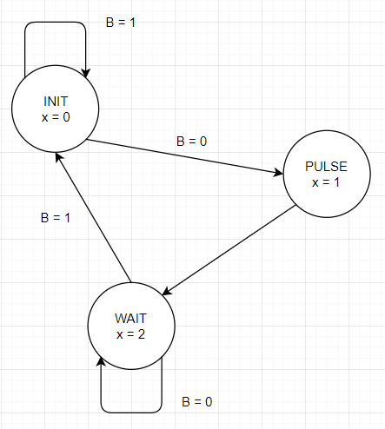

Figure 4: FSM for Button Shaper

Button Shaper

button_input

rst result

clk

Figure 5: Block Diagram

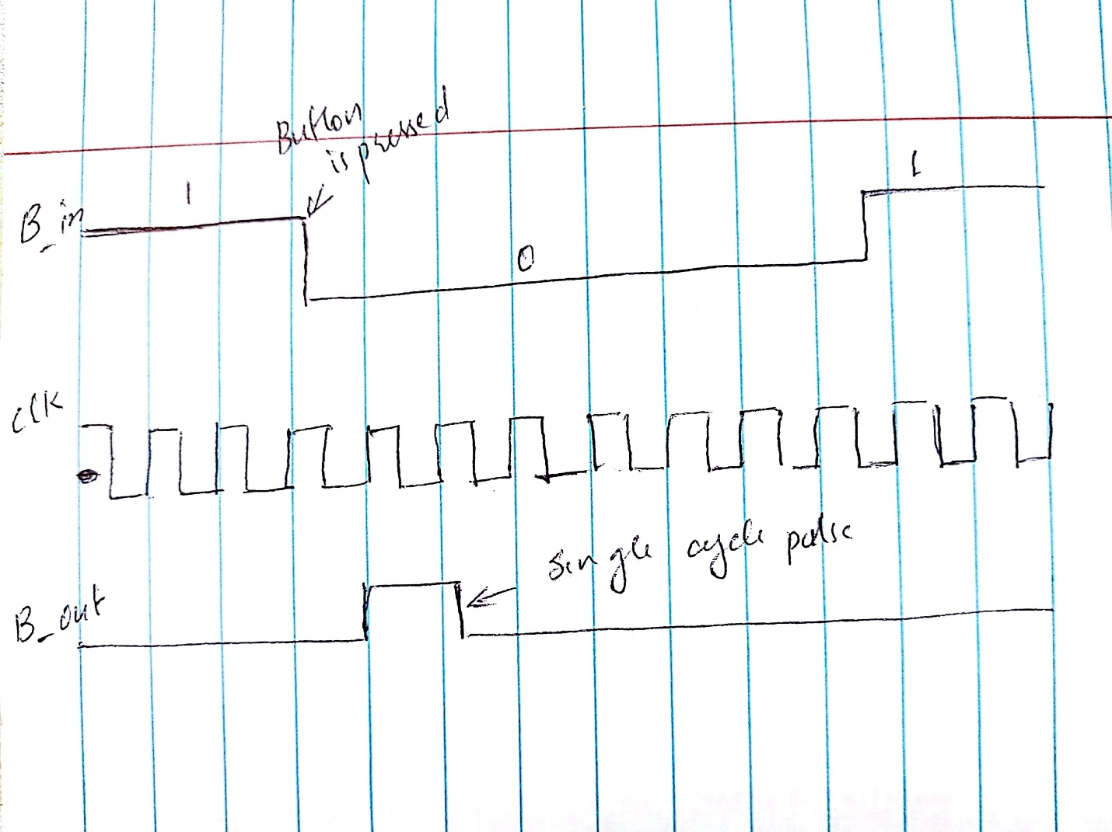

Figure 6: Expected behavior of a button shaper

## 2. Access Controller

Access Controller module will be designed using a sequential circuit to authenticate user. There are five states in this system.

|  |  |
| --- | --- |
| **State** | **Description** |
| INIT | This is the default state when button is not pressed, and output remain low. It then checks the first digit of stored password and moves to DIGIT1. Initial value of check_flag = 1. If comparison does not match, check_flag = 0. |
| DIGIT1 | System reach this state if value stored in password to be compared against 1st digit gives positive result. It then checks the second digit of stored password and moves to DIGIT2. If comparison does not match, check_flag = 0. |
| DIGIT2 | System reach this state if value stored in password to be compared against 2nd digit gives positive result. It then checks the third digit of stored password and moves to DIGIT3. If comparison does not match, check_flag = 0. |
| DIGIT3 | System reach this state if value stored in password to be compared against 3rd digit gives positive result. It then checks the fourth digit of stored password and moves to FINAL. If comparison does not match, check_flag = 0. |
| FINAL | System reaches this state from any of the previous state. It checks value of check_flag to decide whether lit up green/red led. It also acts as a stage to load timer value by pressing password button again. It also serves as a comeback state after timeout happens and then user can reset the timer value. |
| TIMER | System reaches this stage when user is authenticated and has set timer value. Systems continues in this state loading player and random number value until timer hits 0. Once timer hits 0, then system goes back to state FINAL. |

When button is pressed, the system accepts the input password digit and checks with the respective digit stored. If comparison matches it moves forward to next state. In all states, password is compared against stored value and check_flag is set accordingly.

|  |  |  |  |
| --- | --- | --- | --- |
| **SL No:** | **Parameter Name** | **Type of Parameter** | **Description** |
| 1 | Button_input | Input | Defines the action of a button. It goes low when button is pressed and remains high when button Is not selected |
| 2 | Clk | Input | Defines the clock signal for the sequential circuit. |
| 3 | Rst | Input | Defines reset signal which would reset the state to INIT when it is low. |
| 4 | Password | Input | Defines each digit of the 4 digit password. |
| 5 | Current_state | Register | Defines the current state of the system. |
| 6 | Load_player1_inp | Input | Defines the load value of player 1 that will be shown in output if password matches. |
| 7 | Load_player2_inp | Input | Defines the load value of player 2 that will be shown in output if password matches. |
| 8 | Load_player1_out | Output | Defines the output load value of player 1 that will be show load_player1_inp as output if password matches. Otherwise it is zero. |
| 9 | Load_player2_out | Output | Defines the output load value of player 2 that will be show load_player2_inp as output if password matches. Otherwise it is zero. |
| 10 | Timeout | Input | Indicates whether timer hit 0 or not. |
| 11 | Access_flag_allow | Output | Represents green led that goes high when password match |
| 12 | Access_flag_allow | Output | Represents red led that goes high when password does not match |
| 13 | timer_tens_input | Input | Defines tens place of the timer value |
| 14 | timer_unit_input | Input | Defines unit place of the timer value that user enter. |
| 15 | timer_tens_output | Output | Defines a load register that stores the input value if user is authorized |
| 16 | timer_unit_output | Output | Defines a load register that stores the input timer unit place if user is authorized. |

Figure 7: Parameter Mapping Table

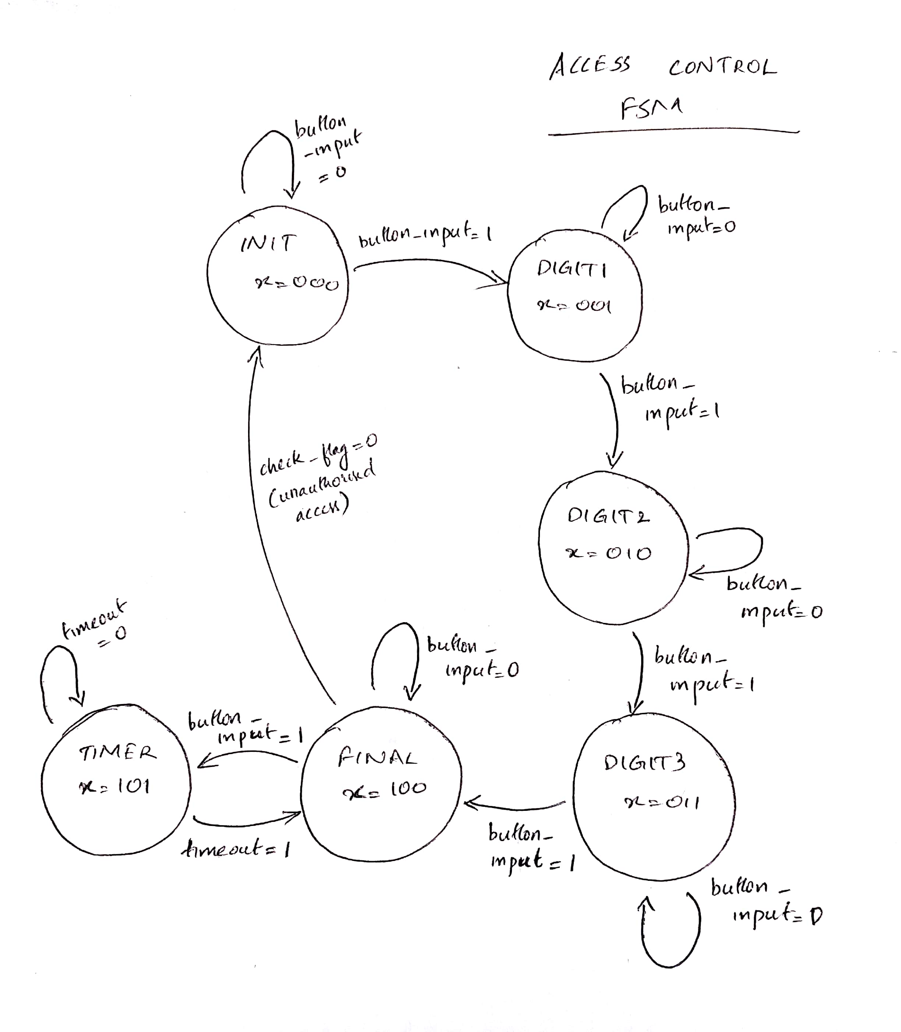

Figure 8: FSM for access control

## Game Controller

This module

Access_control

password

button_input access_flag_allow

timeout access_flag_denied

load_player1_inp load_player1_out

clk load_player2_out

rst timer_unit_output

load_player2_inp timer_tens_output

timer_unit_input

timer_tens_input

Figure 9: Symbol Diagram

## 3. Seven Segment Display

In this module, we are taking 4-bit input and using Verilog, we would generate necessary 7 bit output. 7-segment display has 7 segments that are resembled by 1 bit and is active low. i.e. segment will glow if output bit is 0 and will be off is output bit is 1.

|  |  |  |  |
| --- | --- | --- | --- |
| SL No: | Parameter Name | Type of Parameter | Description |
| 1 | Decoder_in | Input | Defines the input number which would be displayed over 7 segment display. Number can range from 0 – 15 – represented by 4 bits. |
| 2 | Decoder_out | Output | Defines the output bit that would be used to display each segment of the display. The output is of 7 bit. |

Figure 10: Parameter Mapping Table

4 bit

input

Verilog Code

To seven segment

Display

(7 bit output)

Figure 11: Block Diagram

|  |  |  |  |  |  |  |  |  |  |  |  |
| --- | --- | --- | --- | --- | --- | --- | --- | --- | --- | --- | --- |
| **Number** | **Inp3** | **Inp2** | **Inp1** | **Inp0** | **Out6** | **Out5** | **Out4** | **Out3** | **Out2** | **Out1** | **Out0** |
| 0 | 0 | 0 | 0 | 0 | 1 | 0 | 0 | 0 | 0 | 0 | 0 |
| 1 | 0 | 0 | 0 | 1 | 1 | 1 | 1 | 1 | 0 | 0 | 1 |
| 2 | 0 | 0 | 1 | 0 | 0 | 1 | 0 | 0 | 1 | 0 | 0 |
| 3 | 0 | 0 | 1 | 1 | 0 | 1 | 1 | 0 | 0 | 0 | 0 |
| 4 | 0 | 1 | 0 | 0 | 0 | 0 | 0 | 1 | 1 | 0 | 1 |
| 5 | 0 | 1 | 0 | 1 | 0 | 0 | 1 | 0 | 0 | 1 | 0 |
| 6 | 0 | 1 | 1 | 0 | 0 | 0 | 0 | 0 | 0 | 1 | 0 |
| 7 | 0 | 1 | 1 | 1 | 1 | 1 | 1 | 1 | 0 | 0 | 0 |
| 8 | 1 | 0 | 0 | 0 | 0 | 0 | 0 | 0 | 0 | 0 | 0 |
| 9 | 1 | 0 | 0 | 1 | 0 | 0 | 1 | 1 | 0 | 0 | 0 |
| 10 | 1 | 0 | 1 | 0 | 0 | 1 | 0 | 0 | 0 | 0 | 0 |
| 11 | 1 | 0 | 1 | 1 | 0 | 0 | 0 | 0 | 0 | 1 | 1 |
| 12 | 1 | 1 | 0 | 0 | 1 | 1 | 1 | 0 | 0 | 0 | 0 |
| 13 | 1 | 1 | 0 | 1 | 0 | 1 | 0 | 0 | 0 | 0 | 1 |
| 14 | 1 | 1 | 1 | 0 | 0 | 0 | 0 | 0 | 1 | 0 | 0 |
| 15 | 1 | 1 | 1 | 1 | 0 | 0 | 0 | 1 | 1 | 1 | 0 |
| Other case |  |  |  |  | 1 | 1 | 1 | 1 | 1 | 1 | 1 |

Figure 12: Truth Table

## 4. ADDER

This module is used to add two inputs. If the sum is 15 then if green LED output is set HIGH otherwise RED LED is set HIGH. It also gives out sum as an output.

Figure 13: Adder block diagram

Adder Logic

player1 input sum

player 2 input Green LED output

RED LED output

|  |  |  |  |
| --- | --- | --- | --- |
| **SL no:** | **Names** | **Type** | **Description** |
| 1 | Player1 input | Input | A 4bit input for player1 |
| 2 | Player2 input | Input | A 4bit input for player 2 |
| 3. | Sum | Output | A 4bit variable to store sum |
| 4. | Green Led output | Output | A 1bit value that goes high when sum is 15 |
| 5. | Red LED output | Output | A 1bit value that goes high when sum is not 15 |

Figure 14: Parameter Description

## 5. TimerOneSecond

This is timer one second module. It internally calls 100ms counter 10 times and gives out timeout when it is called 10 times.

timer1ms_enable

Figure 15: TimerOneSecond block diagram

TimerOneSecond

clk countTo10_timeout

rst

|  |  |  |  |
| --- | --- | --- | --- |
| **SL no:** | **Names** | **Type** | **Description** |
| 1 | Timer1ms_enable | Input | A 1bit enable signal that is used to start the timer |
| 2 | Clk | Input | Clock signal |
| 3 | Rst | Input | A reset button that resets everything |
| 4 | countTo10_timeout | Output | A single bit output that goes high when timer reaches 1 second |

Figure 16: Parameters description

## 6. TimerLoad

This module is used to load timer value flag if user is authenticated and the password button is pressed after. This is to ensure timer value is not inserted before user is authenticated and password button is pressed again.

Figure 17: TimerLoad block

TimerLoad

Timer_button

Access_allow timer_load

clk

rst

|  |  |  |  |
| --- | --- | --- | --- |
| **SL no:** | **Name** | **Type** | **Description** |
| 1 | Timer_button | Input | A button that goes low when is pushed |
| 2 | Access_allow | Input | A single bit input that says whether user is authenticated or not |
| 3 | Clk | Input | Clock signal |
| 4 | Reset | Input | Reset button |

Figure 18: Parameter description

## 7. TimerForEachDigit

This module is to act as a countdown timer for each digit. It would start decrementing according to the start/stop value coming from Timer module. Once timer reaches 0 it raises a timeout flag. Timer is created in a way that when it reaches 0, it would check if it can borrow from higher digit by raising need_to_borrow flag, if it can, it would recieve can_borrow flag as 1. can_borrow recieve value from can_give of the higher digit module. To set can_give of higher digit module, higher module would check if it is recieving asking_borrow flag as 1. If lower digit module recieve can_borrow as 1, then digit value is set to 9 and continues decrementing. Finally, it is not recieving can_borrow as 1, then timeout flag is set 1.

Figure 19: TimerForEachDigit block diagram

TimerForEachDigit

Timer_input_digit

can_borrow timer_output_digit

asking_borrow need_to_borrow

start timeout

clk can_give

rst stop

|  |  |  |  |
| --- | --- | --- | --- |
| **Sl no:** | **Name** | **Type of parameter** | **Description** |
| 1. | Timer_input_digit | Input | A 4bit number that denotes one digit of the timer. |
| 2. | Can_borrow | Input | A 1 bit number that goes high if higher digit can donate a borrow. |
| 3. | Asking_borrow | Input | A 1bit number that resemble if lower digit needs to borrow from higher digit |
| 4. | Start | Input | A 1bit number that defines whether a timer need to start or not |
| 5. | Timer_output_digit | Output | A 4bit number that denotes the timer value. This decreases till it reaches 0. |
| 6. | Need_to_borrow | Output | A 1bit number that tells whether lower digit need to borrow from higher digit. |
| 7. | Timeout | Output | A 1bit number that goes high for one cycle when timer reaches 0. |
| 8. | Can_give | Output | A 1bit number that tells whether higher digit can give borrow to lower digit |
| 9. | Stop | Output | A 1bit number that tells whether timer need to stop or not. |

Figure 20: Parameter description

## 8. Timer100ms

This is a 100ms timer module. This operation is done by instantiating 1ms module and countTo100 module. Then it would use countTo100 module to call timer1ms module 100 times.

Timer100ms

timer1ms_enable

clk countTo100_timeout

rst

Figure 21: Timer100ms block diagram

|  |  |  |  |
| --- | --- | --- | --- |
| **Sl no:** | **Name** | **Type of parameter** | **Description** |
|  | Timer1ms_enable | Input | A 1bit value that is used to start counter |
|  | CountTo100_timeout | Output | A 1bit value that is used to denote whether counter reached 0 or not |

Figure 22: Parameter description

## 9. Timer1ms

This module is counter that counts from 0 - 49999 and then goes back to 0 to start over. This action continues until enable is made 0. Once counter reaches 49999, a timeout pulse is set to 1 for one cycle. The limit value 49999 is calculated from frequency of 50Mhz and required time of 1ms.

Figure 23: Timer1ms block diagram

Timer100ms

enable

clk timeout

rst

|  |  |  |  |
| --- | --- | --- | --- |
| **Sl no:** | **Name** | **Type of parameter** | **Description** |
| 1. | Enable | Input | A 1bit value that is used to start the counter |
| 2. | Timeout | Output | A 1bit value that goes high to indicate counter has reached 100ms. |

Figure 24: Parameter Description

## 10.Timer

This is the top timer module which would instantiate timerforeachdigit module for unit place and tens place. This module is also responsible for loading timer value only once after user authentication. This is to avoid user from re-entering the value after timer is started. User can reset the value after timer reached 0.

Figure 25: Timer block

Timer

Timer_input_place

Timer_tens_place timeout_unit

start_timer

Timer_output_digit_tens

timer_loaded

Timer_output_digit_unit

clk

rst

|  |  |  |  |
| --- | --- | --- | --- |
| **Sl no:** | **Parameter Name** | **Type of Parameter** | **Description** |
| 1. | Time_input_place | Input | A 4-bit input value that is used to store unit place |
| 2. | Time_tens_place | Input | A 4-bit input value that is used to store tens place |
| 3. | timer_loaded | Input | A 1-bit input value that is to define whether timer is loaded or not. |
| 4. | Timeout_unit | Output | A 1-bit output value that is high when timer is 00. |
| 5. | Timer_output_digit_tens | Output | A 4-bit output value that is used to store tens place. |
| 6. | Timer_output_digit_unit | Output | A 4-bit output value that is used to store unit place. |
| 7. | Start_timer | Input | A 1-bit output value that is define when timer needs to start. |

Table 1: Parameter Description

## 11.successRounds

This module receives input from access controller and adder module then checks if the sum is 15. If yes, then score count, a two 4bit output, is increment. If score value is more than 99, then value is reset to 0.

successRounds

rst totalPoints_ten

player2_button_input

sum

clk totalPoints_unit

|  |  |  |  |
| --- | --- | --- | --- |
| **SL no:** | **Parameter Name** | **Type of Parameter** | **Description** |
| 1. | Clk | Input | Clock signal |
| 2 | Rst | Input | A 1-bit value to reset the system |
| 3 | Player2_button_input | Input | A 1-bit value to check if player has entered a value. This also checks from counting a input unless user has selected that input. |
| 4 | Sum | Input | A 4-bit value that indicates the sum of input value and random number. If sum is 15 then score board is increment. |
| 5. | totalPoints_ten | Output | A 4-bit value that indicates the tens place of the score board. |
| 6 | totalPoints_unit | Output | A 4-bit value that indicates the units place of the score board. |

Table 2: Parameter Description

## 12.RandomNumberGen

This module generates a random number between 0 - 15 according to the duration the button is pressed.

RandomNumberGen

button_input

clk random_number

rst

|  |  |  |  |
| --- | --- | --- | --- |
| **SL no:** | **Parameter Name** | **Type of Parameter** | **Description** |
| 1. | button_input | Input | A 1-bit input that is used to generate random number. |
| 2 | random_number | Output | A 4-bit output number that is equal to number of cycles button_input stays 1. |

Table 3: Parameter Description

## 13.CountTo100

This module is counter that counts from 0 - 99 and then goes back to 0 to start over. This action continues until enable is made 0. Once counter reaches 100, a timeout pulse is set to 1 for one cycle.

CountTo100

count

clk timeout

rst

|  |  |  |  |
| --- | --- | --- | --- |
| **SL no:** | **Parameter Name** | **Type of Parameter** | **Description** |
| 1. | Count | Input | A 1-bit input that is used to count. |
| 2 | Timeout | Output | A 1-bit input that is used to check if count has reached 100. |

Table 4: Parameter Description

## 14. CountTo10

This module is counter that counts from 0 - 9 and then goes back to 0 to start over. This action continues until enable is made 0. Once counter reaches 10, a timeout pulse is set to 1 for one cycle.

CountTo10

count

clk timeout

rst

|  |  |  |  |
| --- | --- | --- | --- |
| **SL no:** | **Parameter Name** | **Type of Parameter** | **Description** |
| 1. | Count | Input | A 1-bit input that is used to count. |
| 2 | Timeout | Output | A 1-bit input that is used to check if count has reached 10. |

Table 5: Parameter Description

# **System Architecture**

The system consists of mainly three modules that takes in the input, process it and displays using 7 segment displays. The modules are:

1. Lab3_4696: This is the top module that invokes all other submodules to bring gaming experience for the user.
2. Adder: This module takes in two 4-bit input and returns sum of two numbers in 4bit. This is used to sum up the player input and random number generated
3. Seven-segment: this module is used to light the 7 segment displays. The module takes in 4bit input number entered by player or calculated by the program and converts in to 7 bits. These bits are then displayed in 7 segment display.
4. Access_control: This module takes in 4-bit password digit and checks with the stored value. If password does not match check_flag = 0. Otherwise check_flag remains at 1. Once user is authenticated, this module is responsible for entering timer value and checking if timer value has reached. If timer has hit zero, it provides user an option to reset timer without logging out of game.
5. LoadRegister: this module is used to load player1 and player2 input to register upon receiving load signal. Load signal is controlled by button shaper
6. Button_shaper: this module is used to convert button press to convert a long low pulse to a single cycle high pulse when a button is pushed.
7. TimerOneSecond: This module is invoked by Timer module to get one second interval pulse. This is used to count till the timer value given by user.
8. TimerForEachDigit (Tens and Unit): This module internally calls TimerOneSecond and is responsible for decrementing tens and units place which are instantiated using two separate TImerforEachDIgit module. This module is also capable of communicating with other TimerForEachDigit module to ask and get carry signal for counting.
9. RandomNumberGen: This module is responsible for generating a random number according to the duration a push button is pressed by user.
10. SuccessRounds: This module is used to count the score. User gets a score when he enters a number that sums up with random number to become 15. If sum is 15, then count is incremented to a maximum of 00. After that it resets to 0.
11. TimerLoad: This module is used to generate start pulse to start the timer digit.
12. Timer: Top module for timer that instantiates two separate modules for tens and units place of timer value. This module also provides a timeout signal to access control and timerload to make sure that user cannot enter anymore value and game is finished

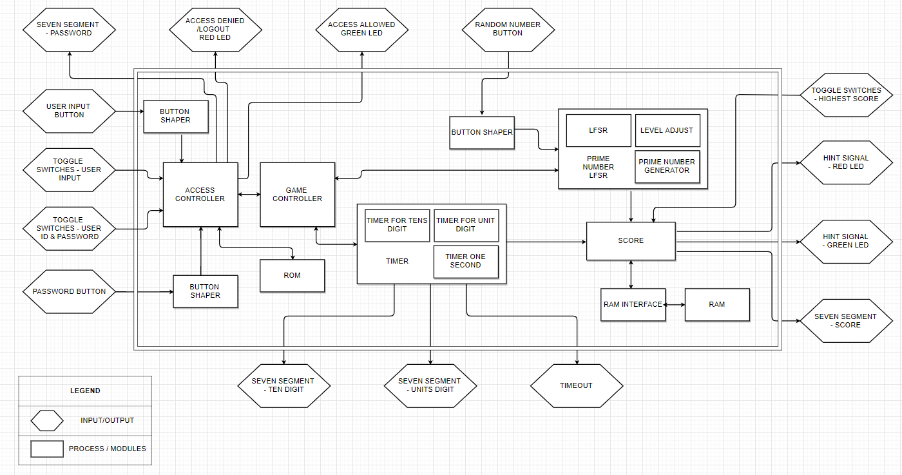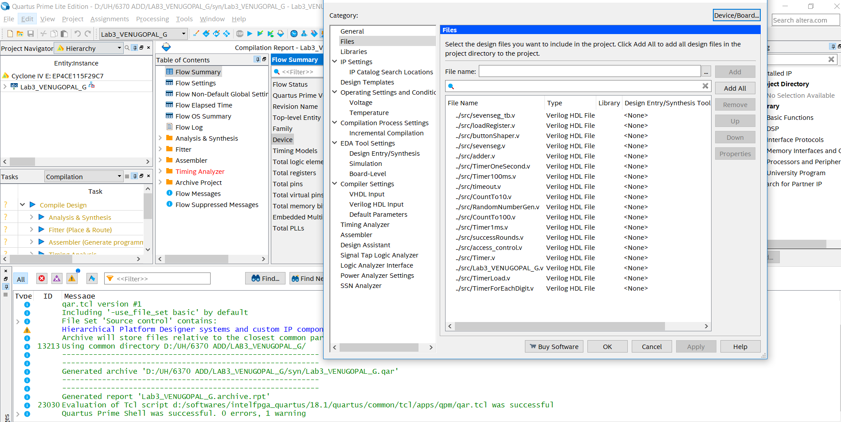

Figure 26: System Architecture. Names are altered for better understanding. Check modules section for exact module names.

Figure 27: Necessary Files are selected.

Screen shot removed since it had too many instance of my identity.

Figure 28: Compiling files in quartus. Status successful

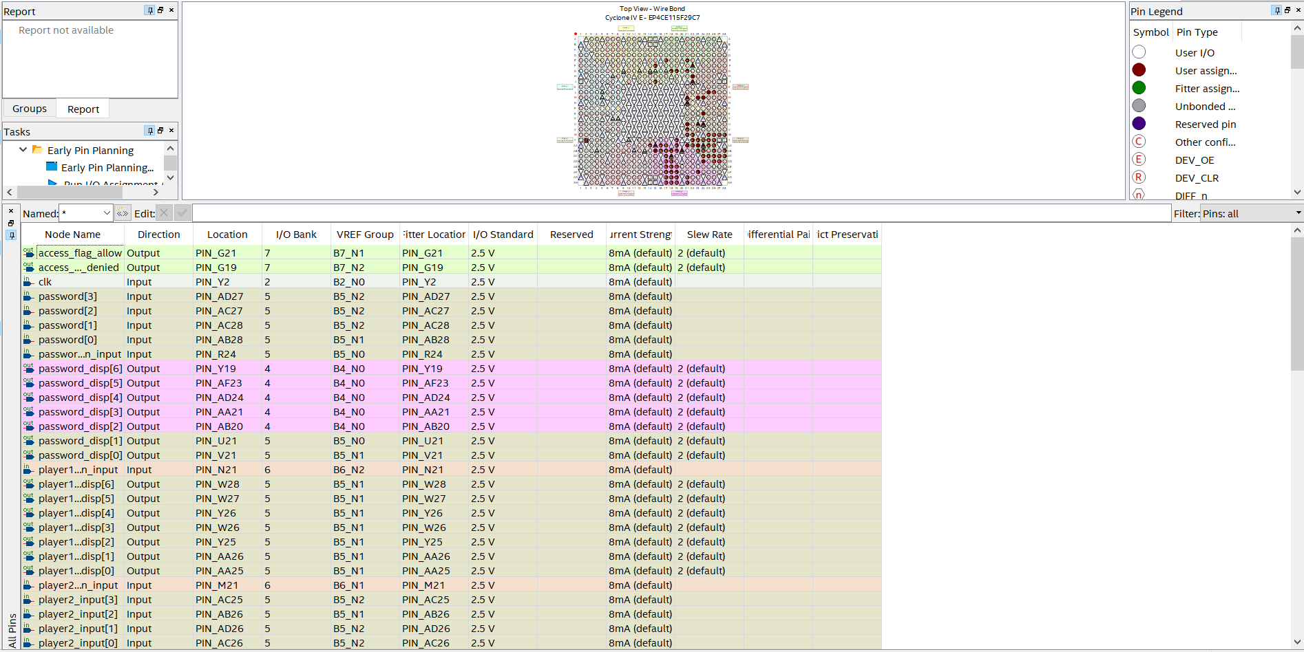

Figure 29: Pin assignment Completed

Screen shot removed since it had too many instance of my identity.

Figure 30: Project Archive in process

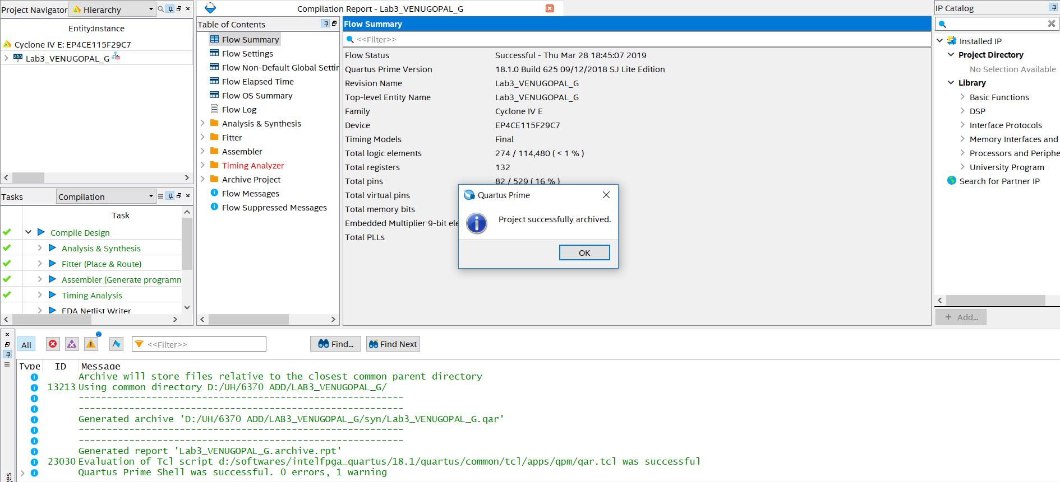

Figure 31: Archive successful

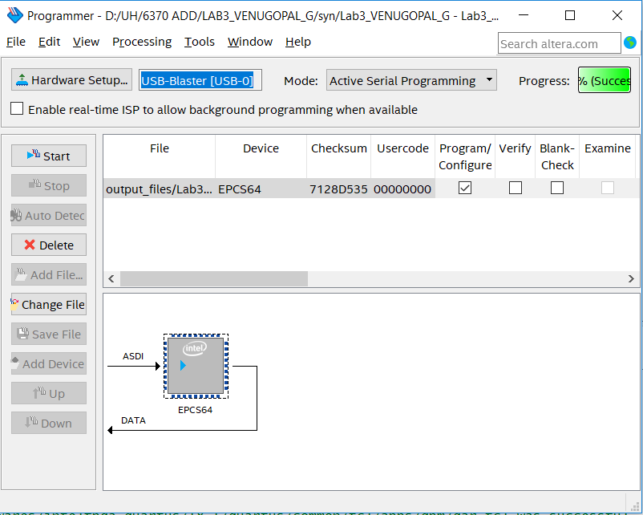

Figure 32: POF file is selected and compilation is completed.

# **SIMULATION**

## Access Control

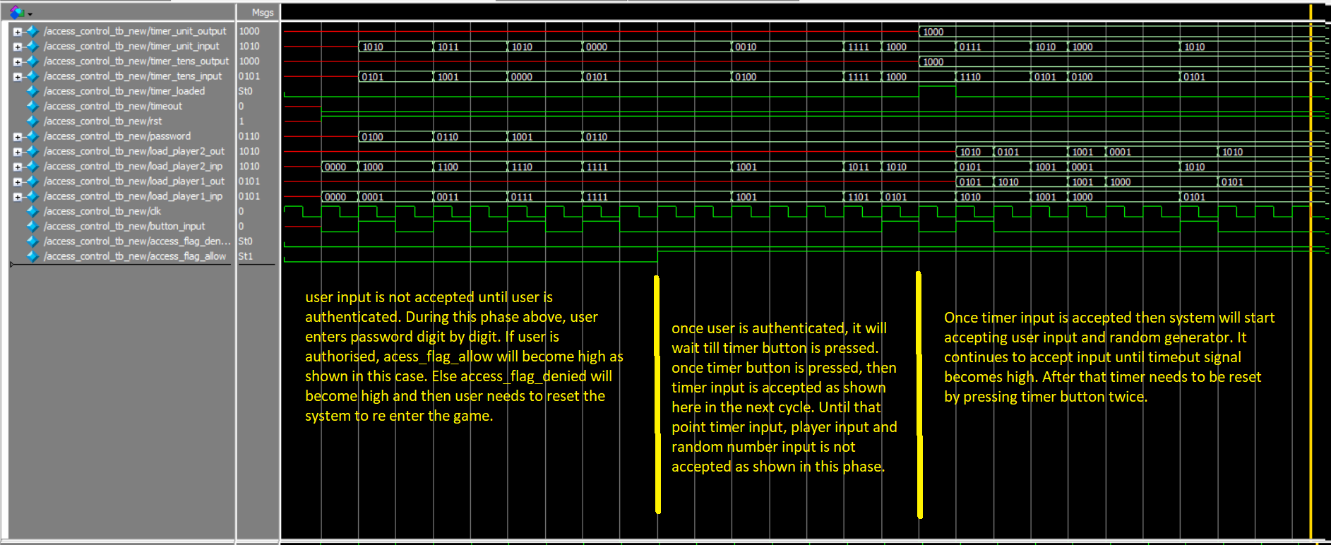Looking at the simulation, we can understand we can understand behavior of the access control. The output goes high when all four digits are correct and green led (shown by access_flag_allow) goes high. Also load register will show value when all digits are correct and timer is loaded by pressing password button. This is marked in the graph.

## Load Register

Looking at the simulation, we can understand the relation between the output and input bits. Output (count) shows value when reset is 1 and load is 1. During this period, value of output will be equal to input. i.e. output variable act as a register which gets loaded when load signal is high.

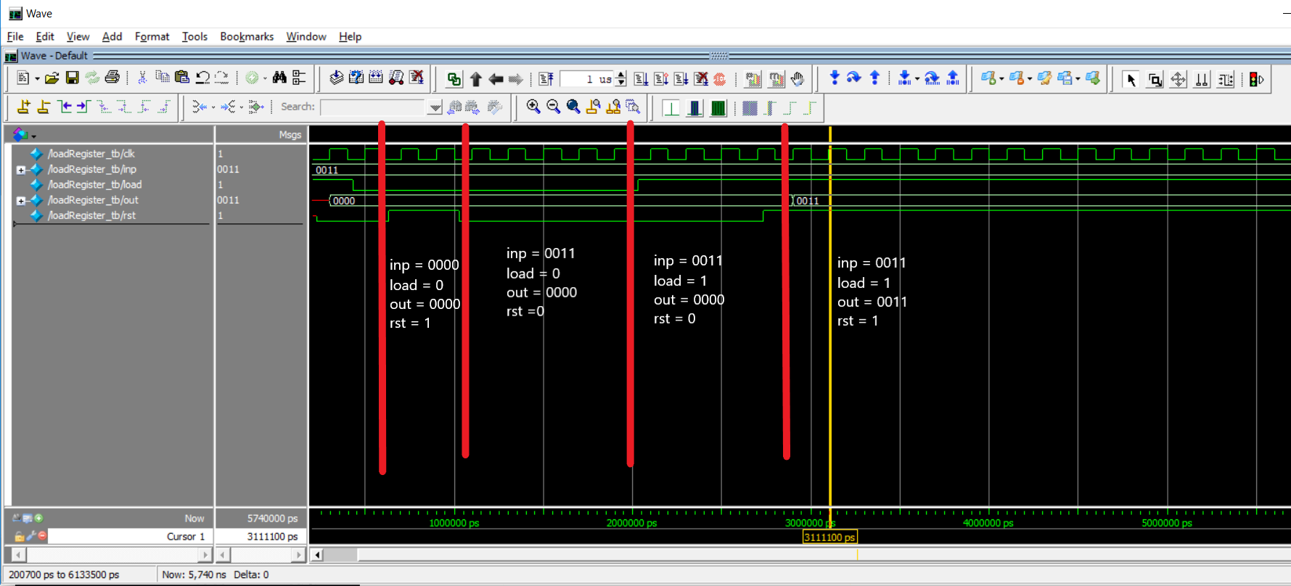

## Button Shaper

Looking at the simulation, we can understand we can understand behavior of the button shaper. The output goes high in the next clock cycle after button is pressed. This is marked in the graph.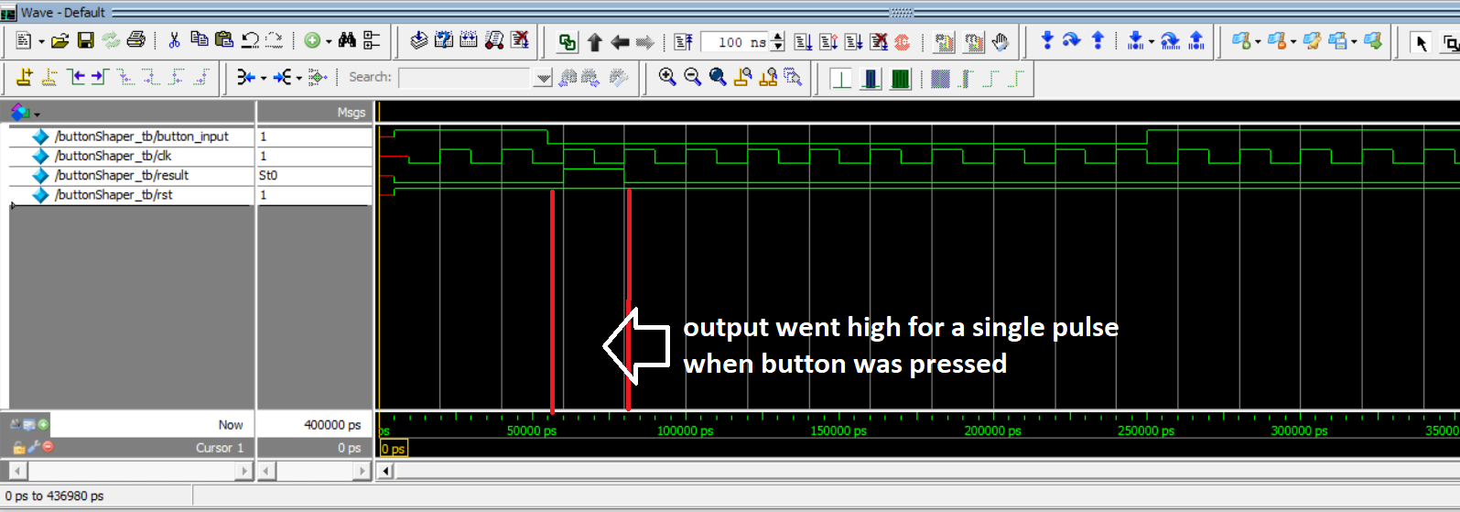

## Seven Segment

Looking at the simulation, we can understand the relation between the output and input bits. Output bits goes high according to the inputs bits that are high.

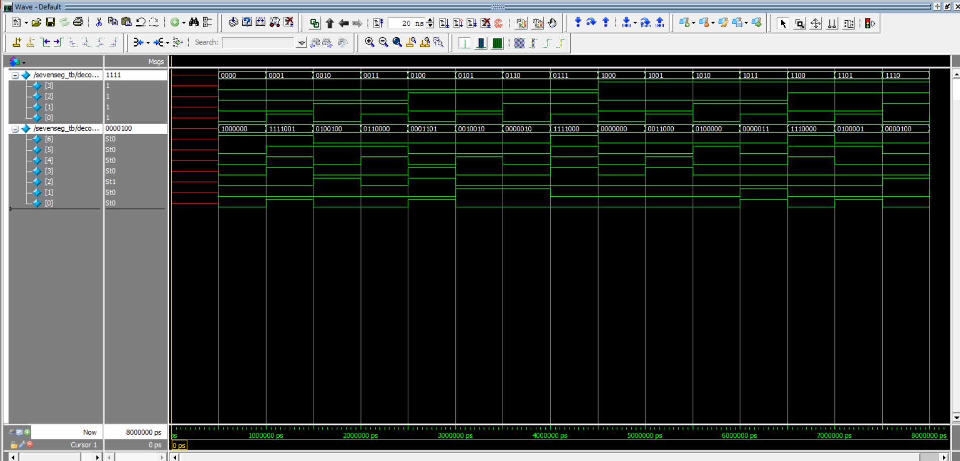

## Random Number Generator

Looking at the graph we can understand that a random number is generated as user presses the random number generator button input. The value of the number is equal to the number of clocks the button is pressed.

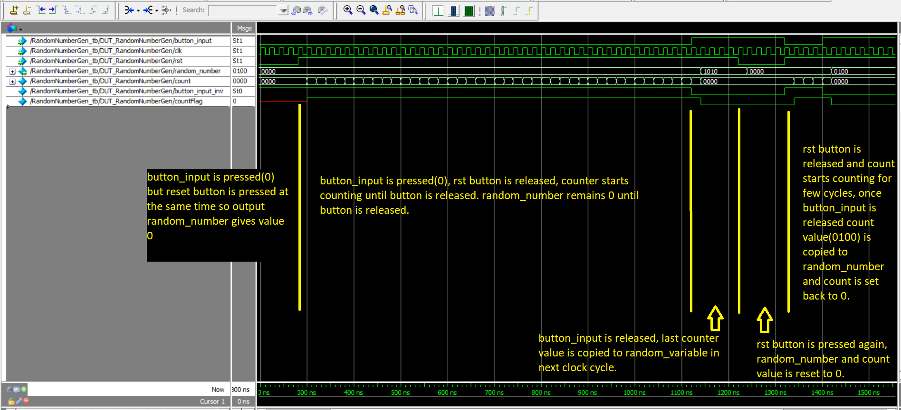

## Timer

As shown here, timer starts when timer load is high and starts counting when timer loaded is low. Once timer hits 0, a timeout signal is sent. This module uses countTo100 module to call timer100ms to get one second pulse. If it gets one second pulse, then timer value is decremented. Due to computational power restriction, timer 1 second was not executed. Instead time scaling has been done to receive similar result without waiting for 1 second simulation.

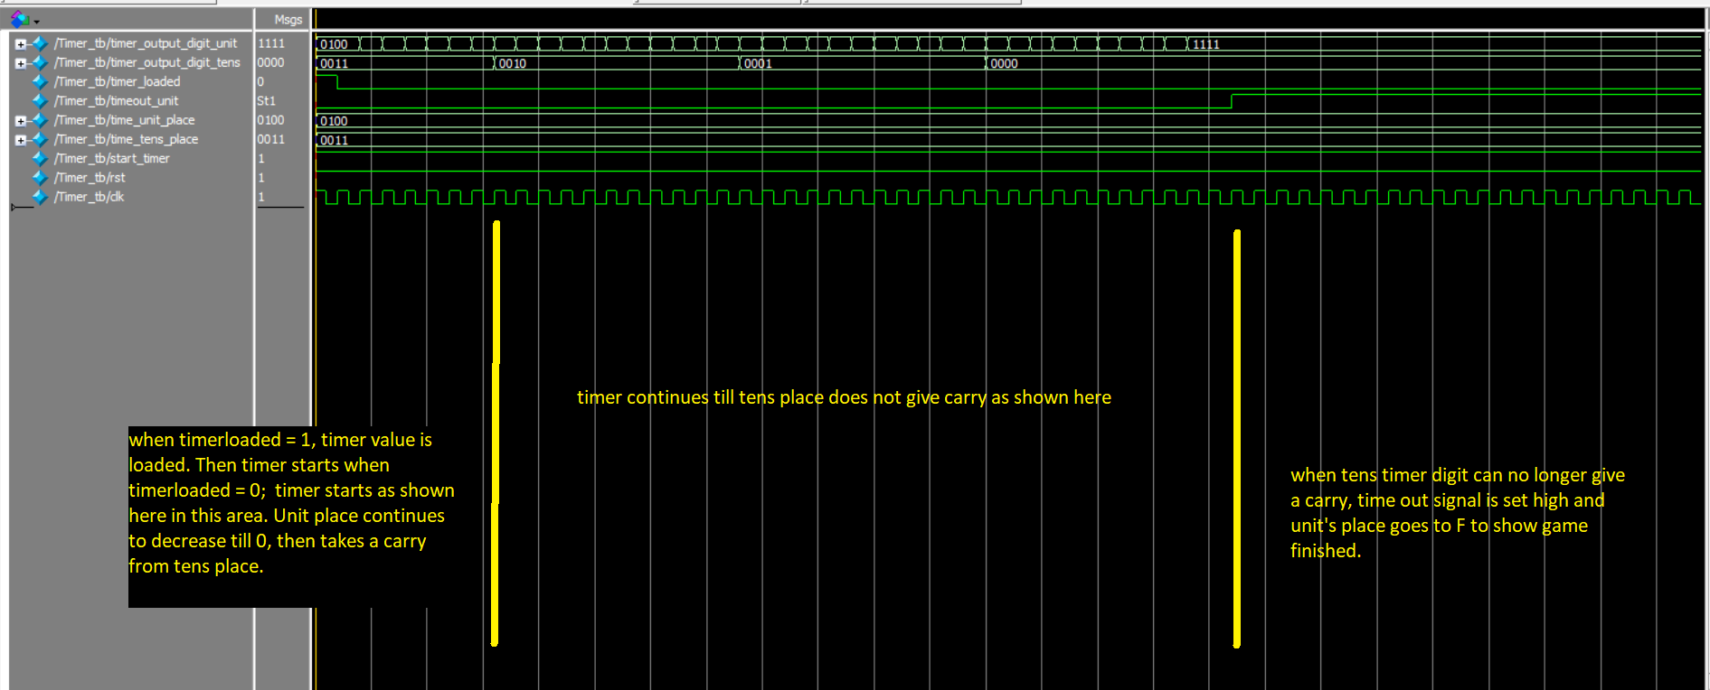

## Timer1ms

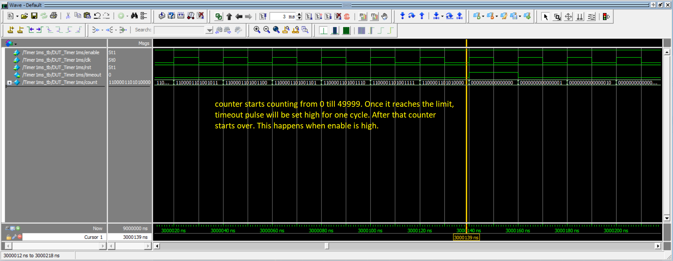As shown below, this module shoots a timeout signal when timer counts will 1ms.

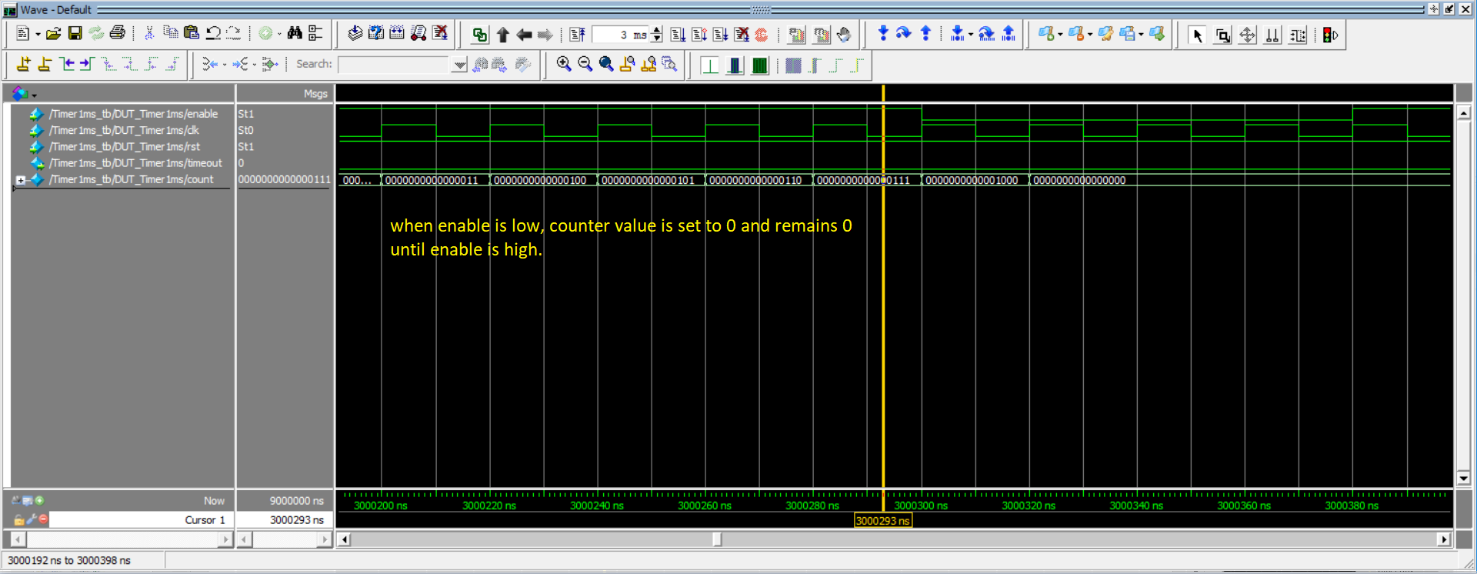

## Count To 100

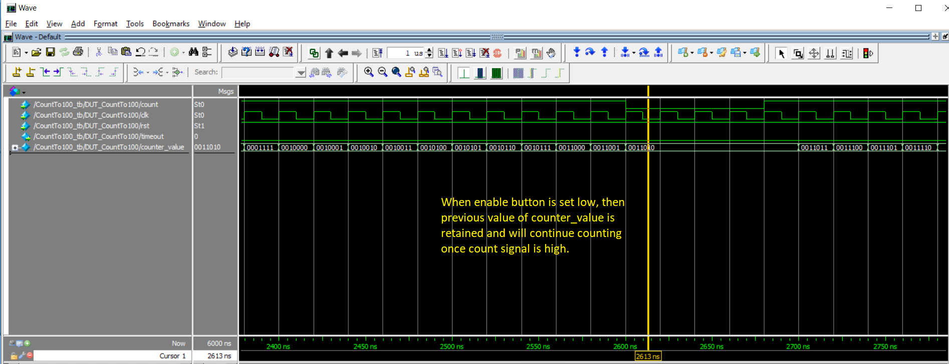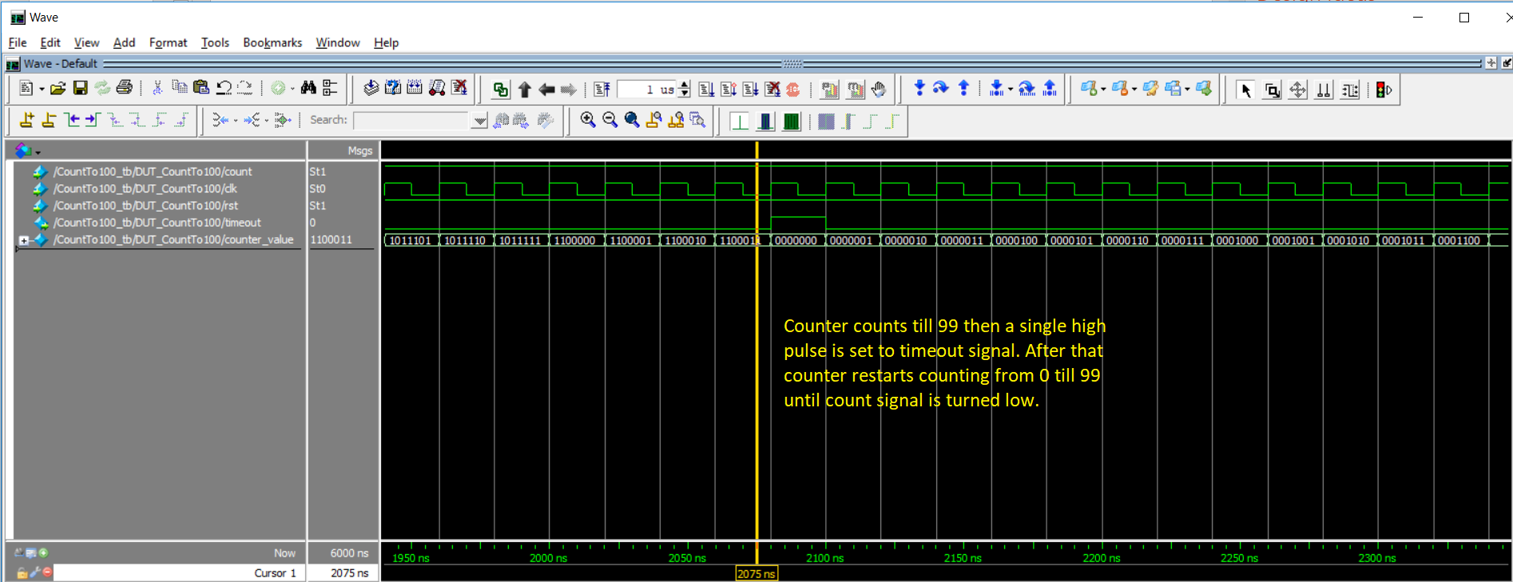This module as shown below, will generate a timeout when counter counts 100.

## Count To 10

This module shoots a timeout signal after executing for 10 times

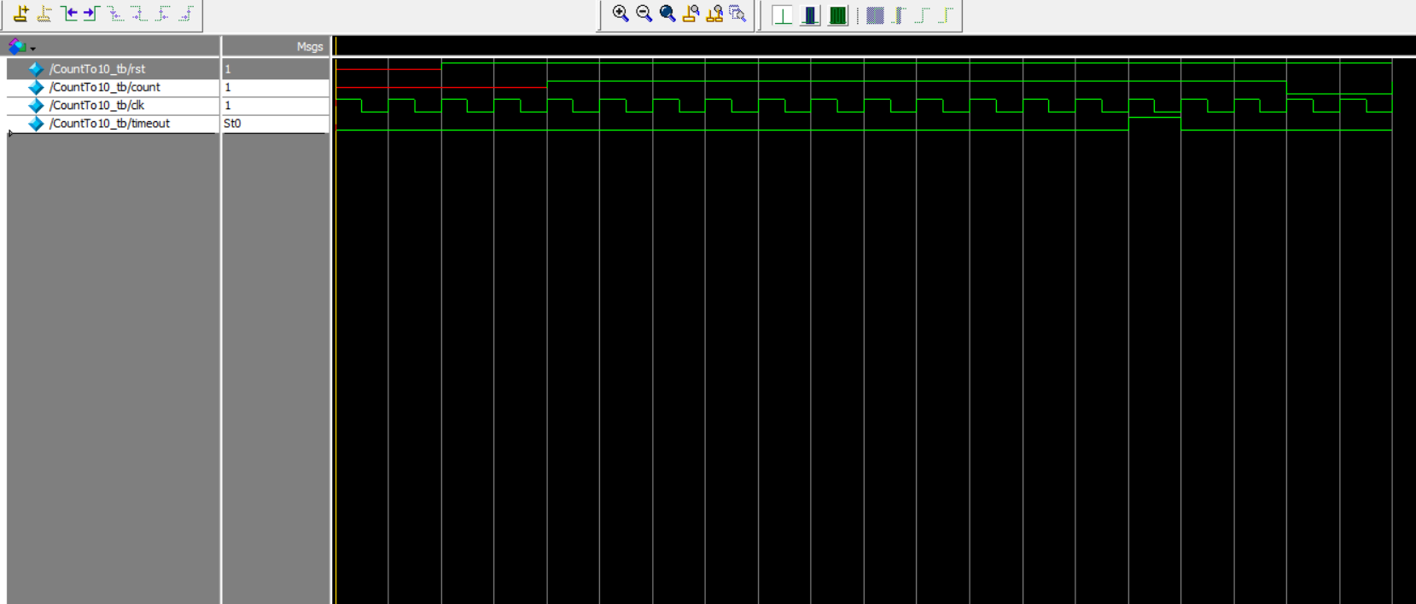

## successRounds

As shown here, score board increments if sum is 15.

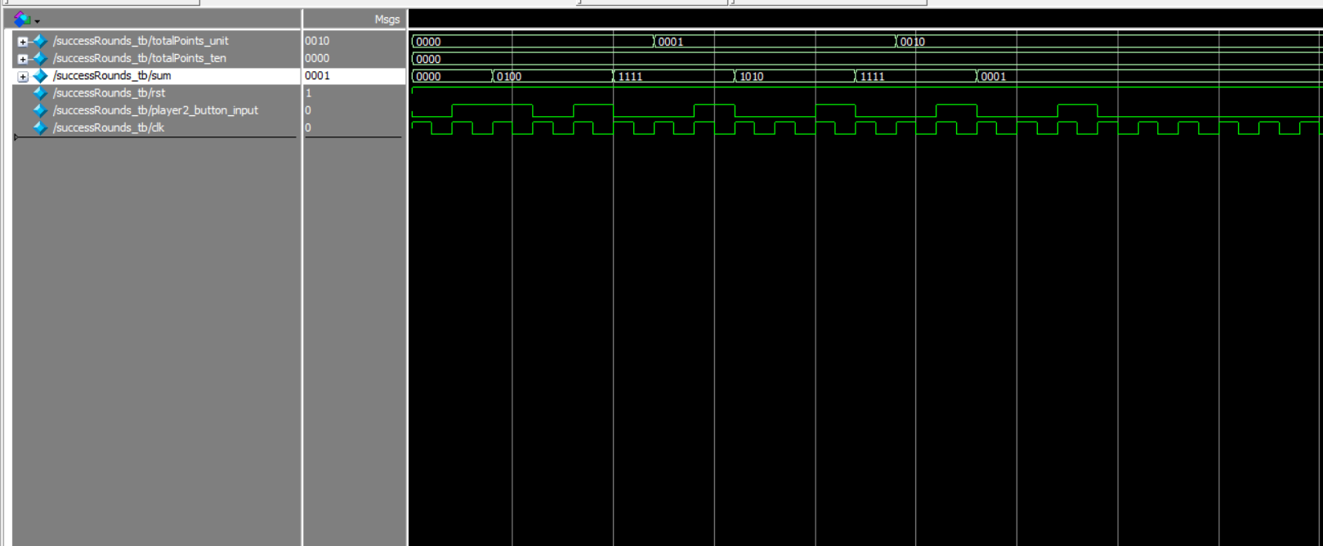

## LAB 3 Top Test Module

This module invokes other module to create game experience. During this period, it authenticates user, accepts timer period, accepts user input and checks for timeout signal to stop the process

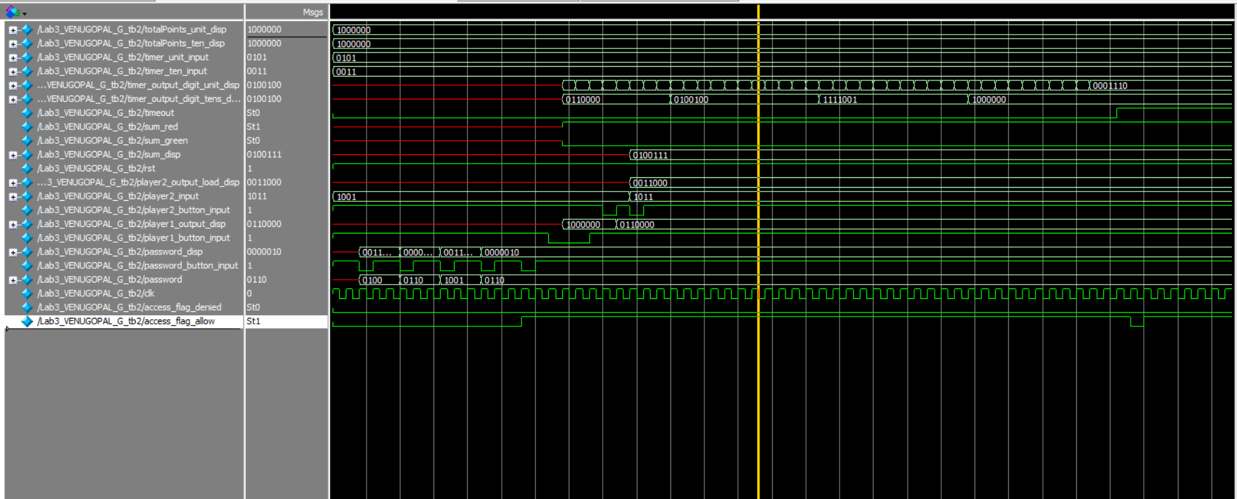

# **FPGA TESTING RESULT**

The above folder contains a single video explaining all modules and functionality of the game system.

First video talks about the layout of the board and how different input/output parameters are configured. Second video walks through how to play the game. First few seconds of the video shows how user enters password and authenticates himself. Once user is authenticated, green led glows up and then user must enter the timer. This is shown in the video by changing the timer switches and then hitting timer button. Then video proceeds to user generating a random number and then user inputs a value. User input, timer, random number, and sum is shown in 7 segments. Video shows multiple cases such as when user enters an input to sum 14 then another green LED lights up and score board increases. If sum is not 15 then a red LED glows an score board in not incremented. Video also shows how much is the max score a user can select that is 99. After that score resets to 0. Also, when timer hits 0, a timeout LED glows up and a F is shown. Video also shows how user must reset the system if he has entered a wrong password.

Lab3_4696

1. First logging in functionality was tested. For this board was turned on. Picture of this state shown in Figure 33. 4-digit password was entered in 4-bit binary form using password input toggles switches shown in Figure 34. Once user logged in Green LED near password button glow up as shown in figure 35.
2. User sets the time and hits timer/password button to start timer and enter game.
3. User can generate random number as shown in Figure 35.
4. User then has to enter a input sum such that the sum is 15. But in Figure 36, we can see that user has failed to get a sum of 15. Then a red LED is shown 38
5. User can select another value to get a sum of 15 as shown 39.
6. User can play again to score another point as shown in Figure 40.
7. Eventhen user can only score a maximum of 99 after that it resets to 0.
8. When timer goes 0, a timeout LED is lit up and F is shown in display as shown in 44.
9. To enter again user has to reset the timer as shown in Figure 43.
10. If user has not been authenticated, the RED Led glows. Then user must press reset to enter back.

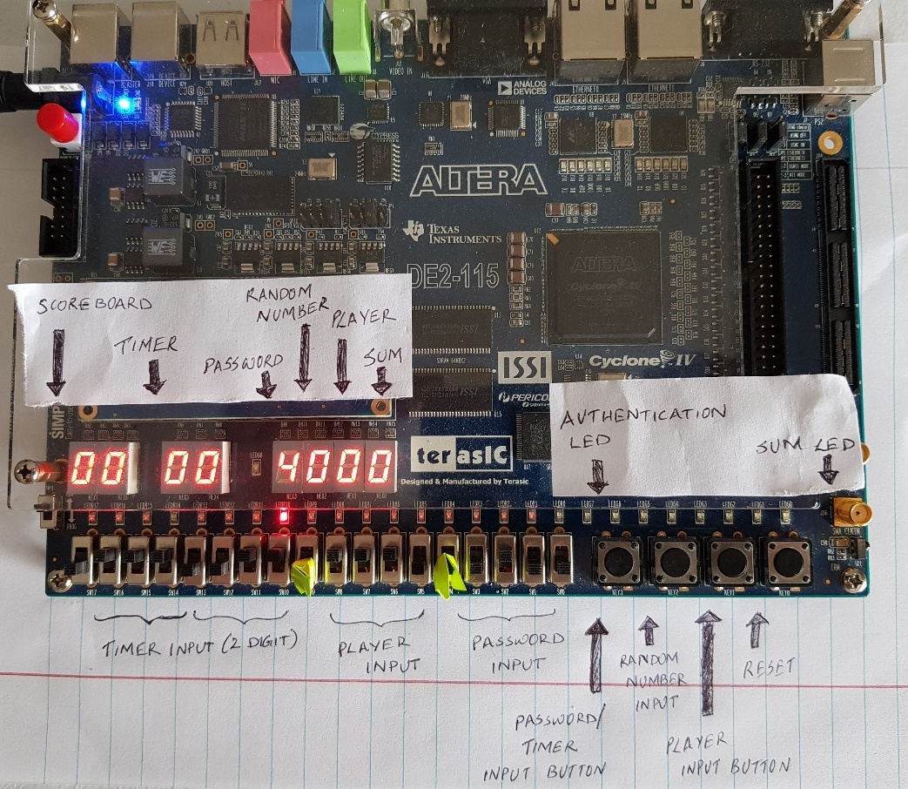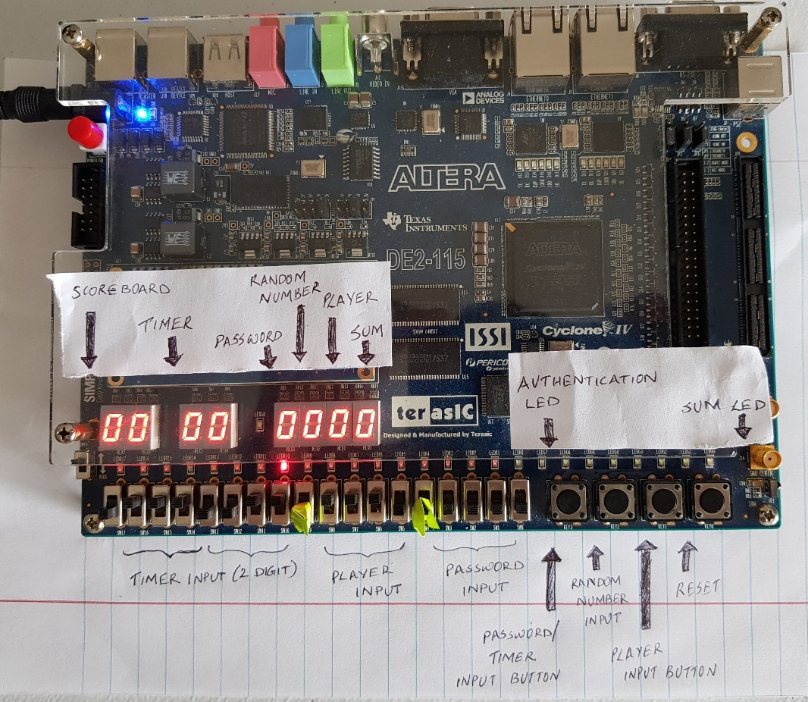

Figure 33: Default/Initial state

Figure 34: Player started entering password. A set of 4 digits need to be entered for authentication.

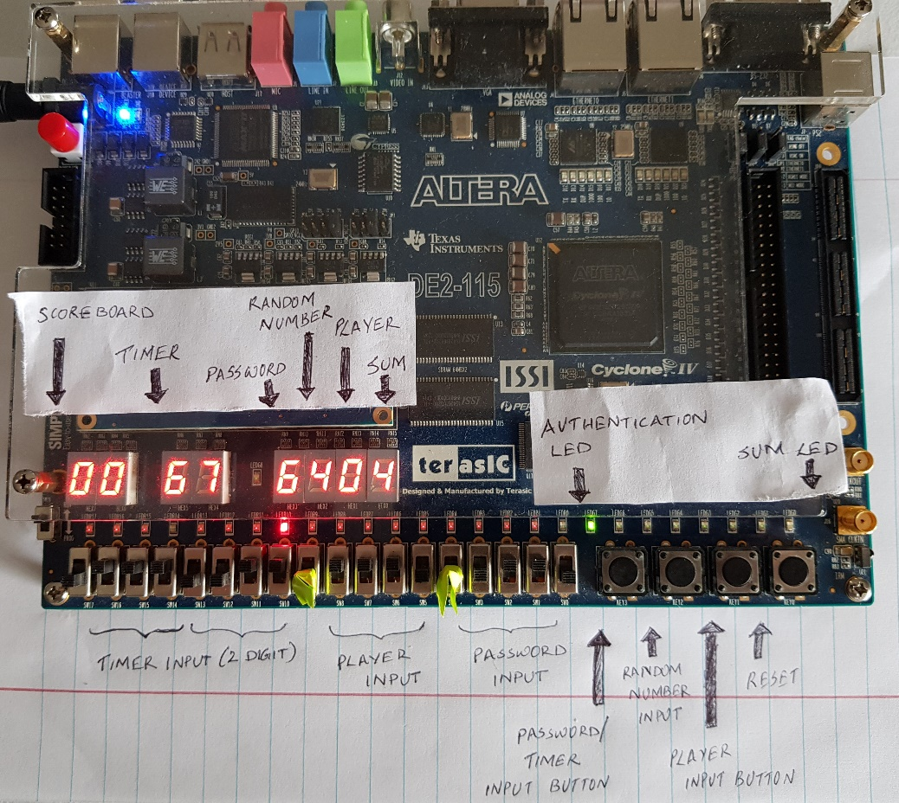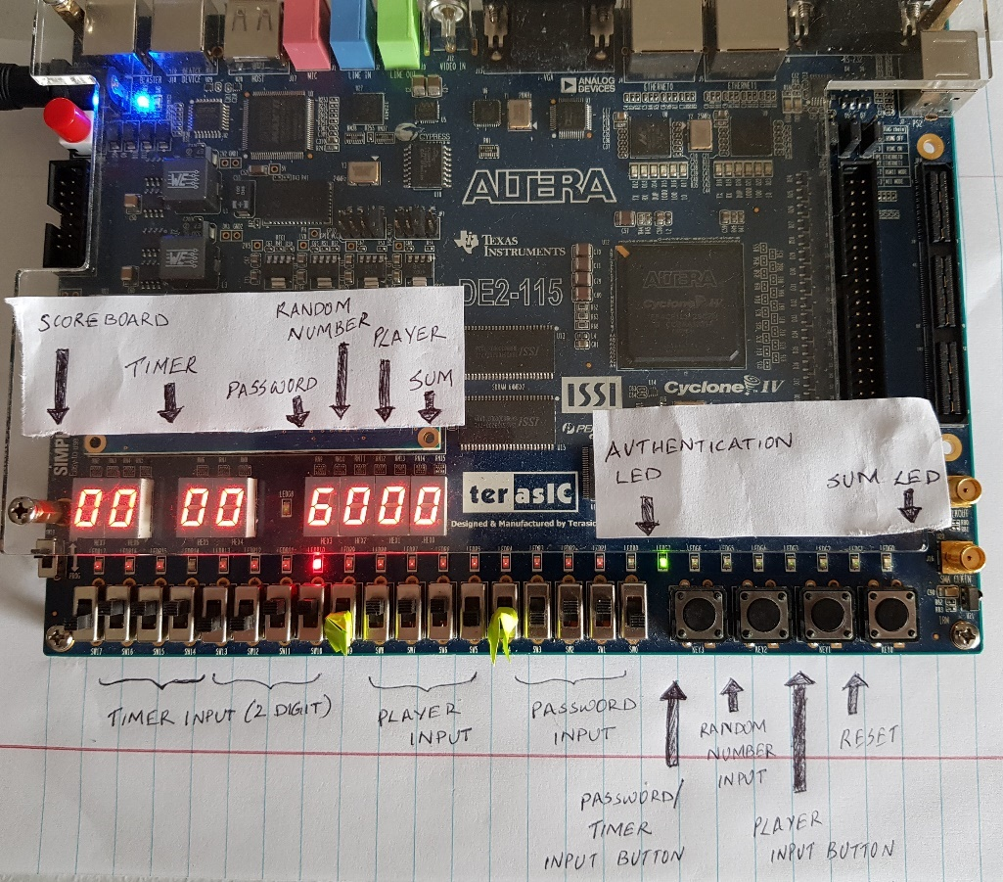

Figure 35: User set timer value by hitting password button and generated a random number by pressing random number input button

Figure 36: User entered right password indicated by authorization GREEN LED.

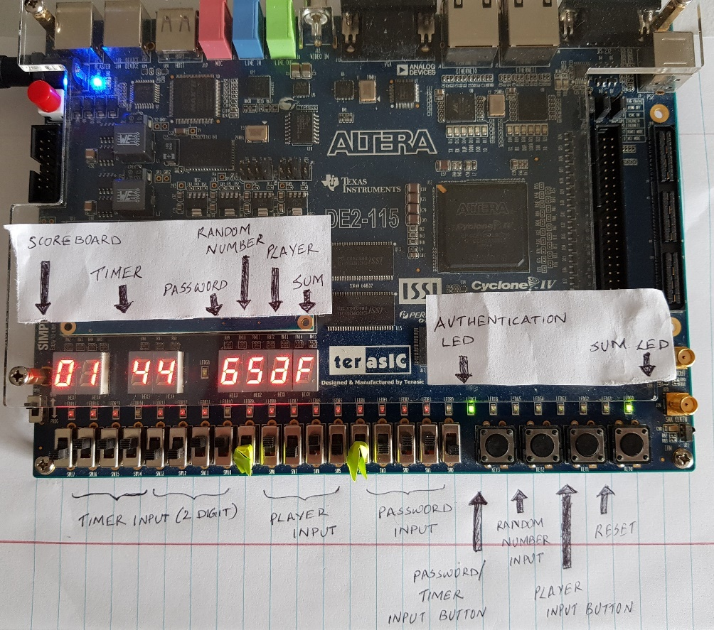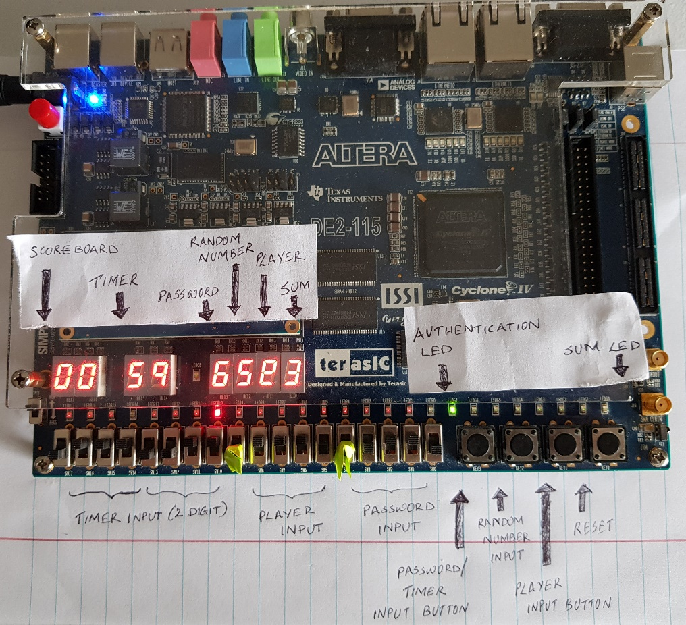

Figure 37: User enters a value that makes sum 15. Sum is displayed on seven segments. Green led is lit up to show sum is 15. Score board increases by 1.

Figure 38: User enters a value to get a sum of 15 but did not reach 15. Sum is displayed and red led is lit up to show sum is not 15.

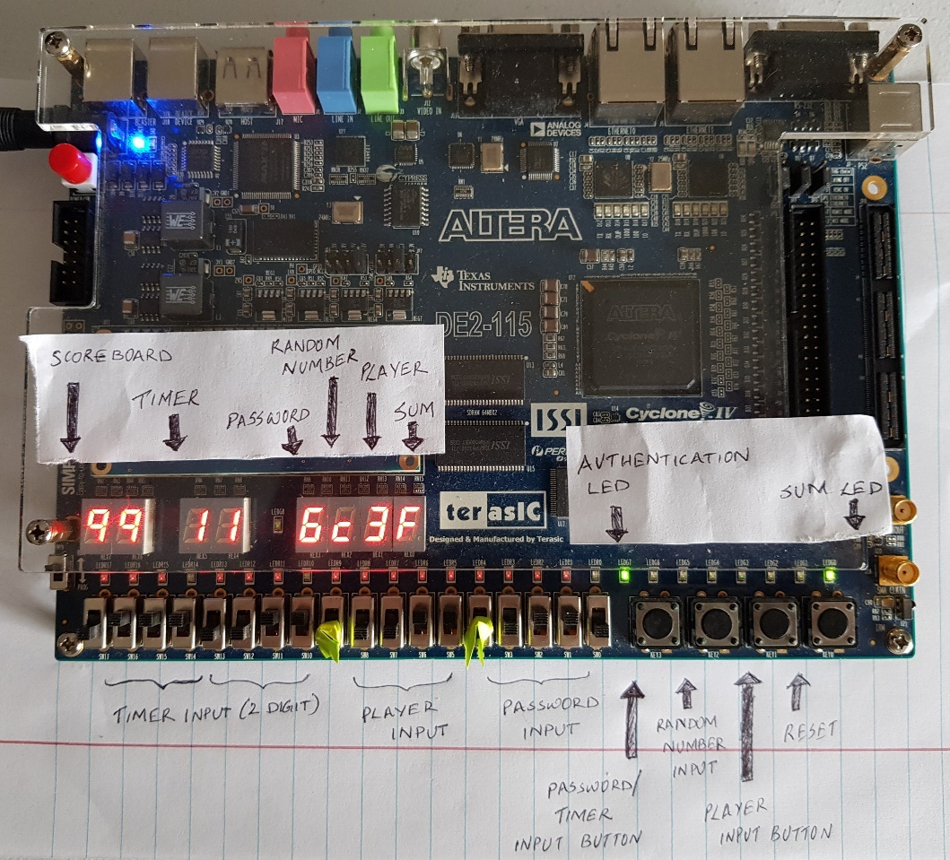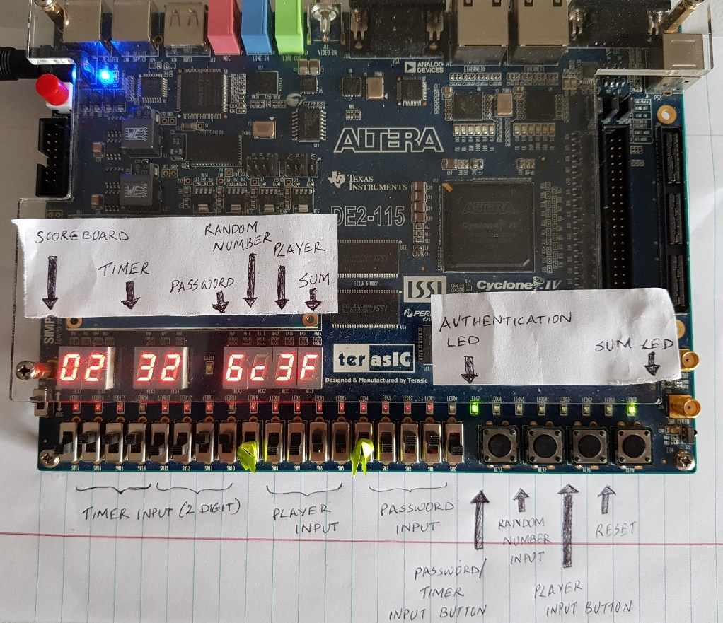

Figure 39: User reached maximum score of 99. Score board resets to 00 after this.

Figure 40: User generates another score indicated by incremented score count.

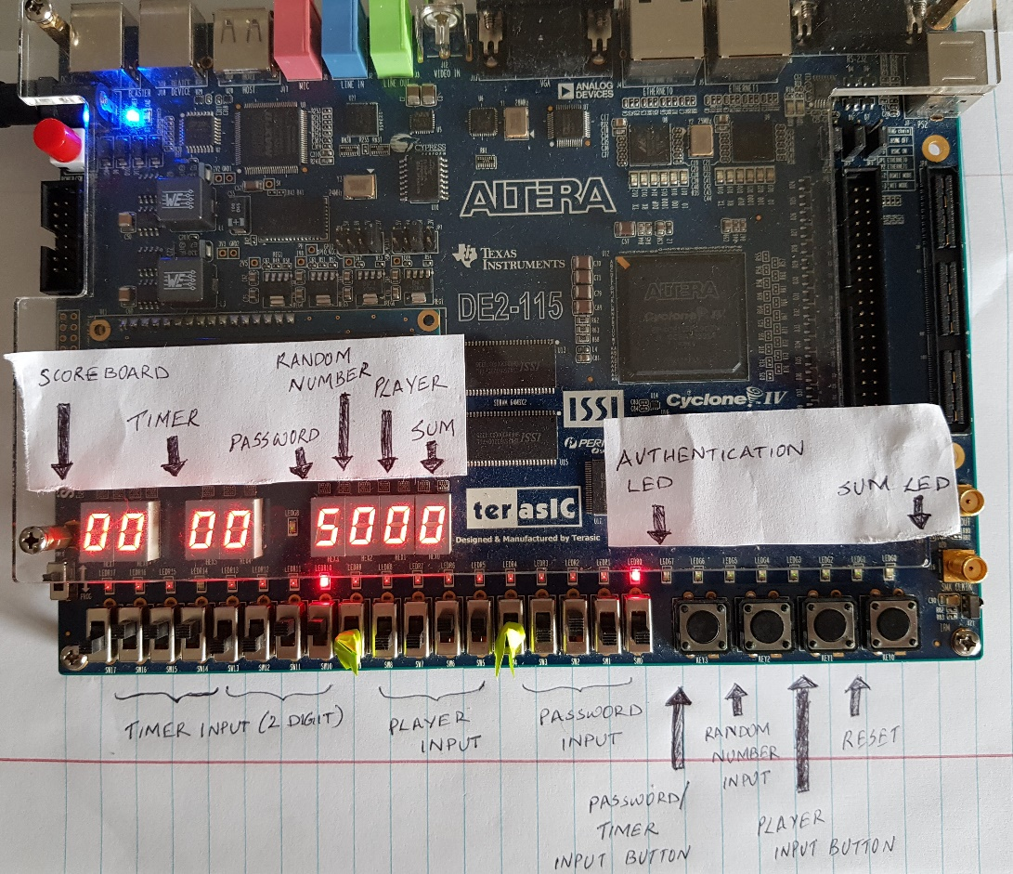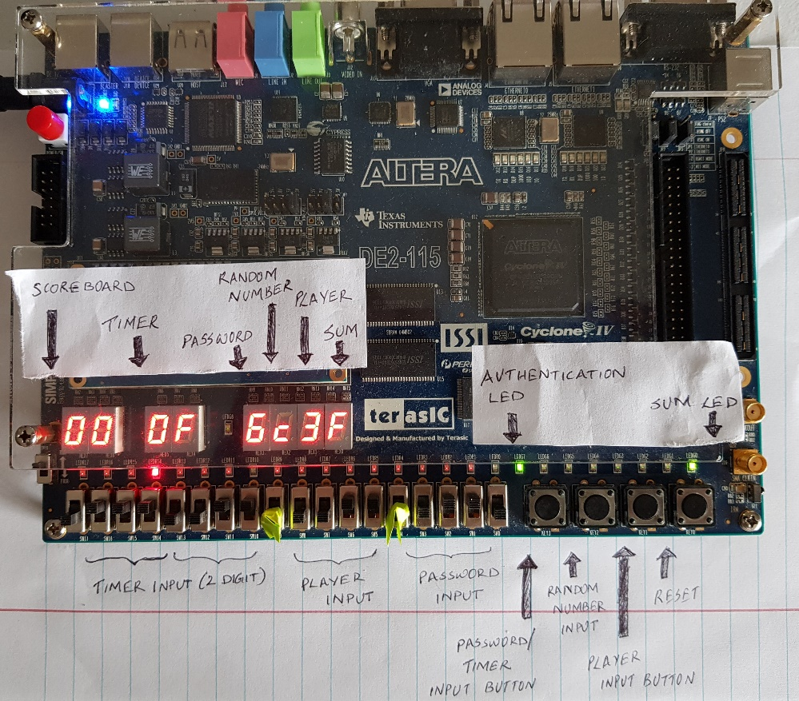

Figure 41: User resets the system to clear everything

Figure 42: Timer reached 0. This is shown by F in timer display to indicate game finished and another RED LED is lit up

# **Conclusion**

This activity was to understand the design and working of game control. While doing activity, I was able to understand how the knowledge on timer, score counter, 7 segment display, access control, adder, button shaper and load register can be used in a real-life scenario like a game. I have also implemented bonus feature score counter using separate module and has tested this feature successfully. I have been able to complete this homework without any error and simulate the graph properly.

# Appendix

# **REFERENCES**

1. Wikipedia - <https://en.wikipedia.org/wiki/Prediction_game>